I. Nature of the inspection
Job No.
¨ First inspection | ¨ Follow-up inspection

II. Details of the machine:
In-house system designation

 | Designation | Type | Ser. No. | Year of  construction | Manufacturer/Supplier | Site
1.
2.
3.

III. Information concerning the scope of the inspection
The inspection was carried out in accordance with the checklist for Tooling Machines, dated 2007-12-10.
IV. Inspection results
¨ The machine / system complies with the with the current FSS 5 checklist.
¨ The machine / system does not meet every requirement of the FSS 5 checklist. However, the machine / system may be used as the functions concerned are not critical in terms of safety.
¨ The machine/ system does not comply with the with the current FSS 5 checklist.
¨ The machine / system will be upgraded.
Initial cost estimate: _______________ Deadline: ____________________
Follow-up inspection required!
¨ The machine / system will be removed from service by _____________ at the latest.
Until this time, technical and / or organizational measures have been implemented to ensure safe operation, as laid down in the attachment.
¨ Date of next regular inspection: ____________________.
V. Distribution list
Responsible person for corrections and improvements:
Responsible person for documentation and files:
VI. Inspection performance
 | Mechanical part | Electrical part | Production | Others
Name
Date
Signature

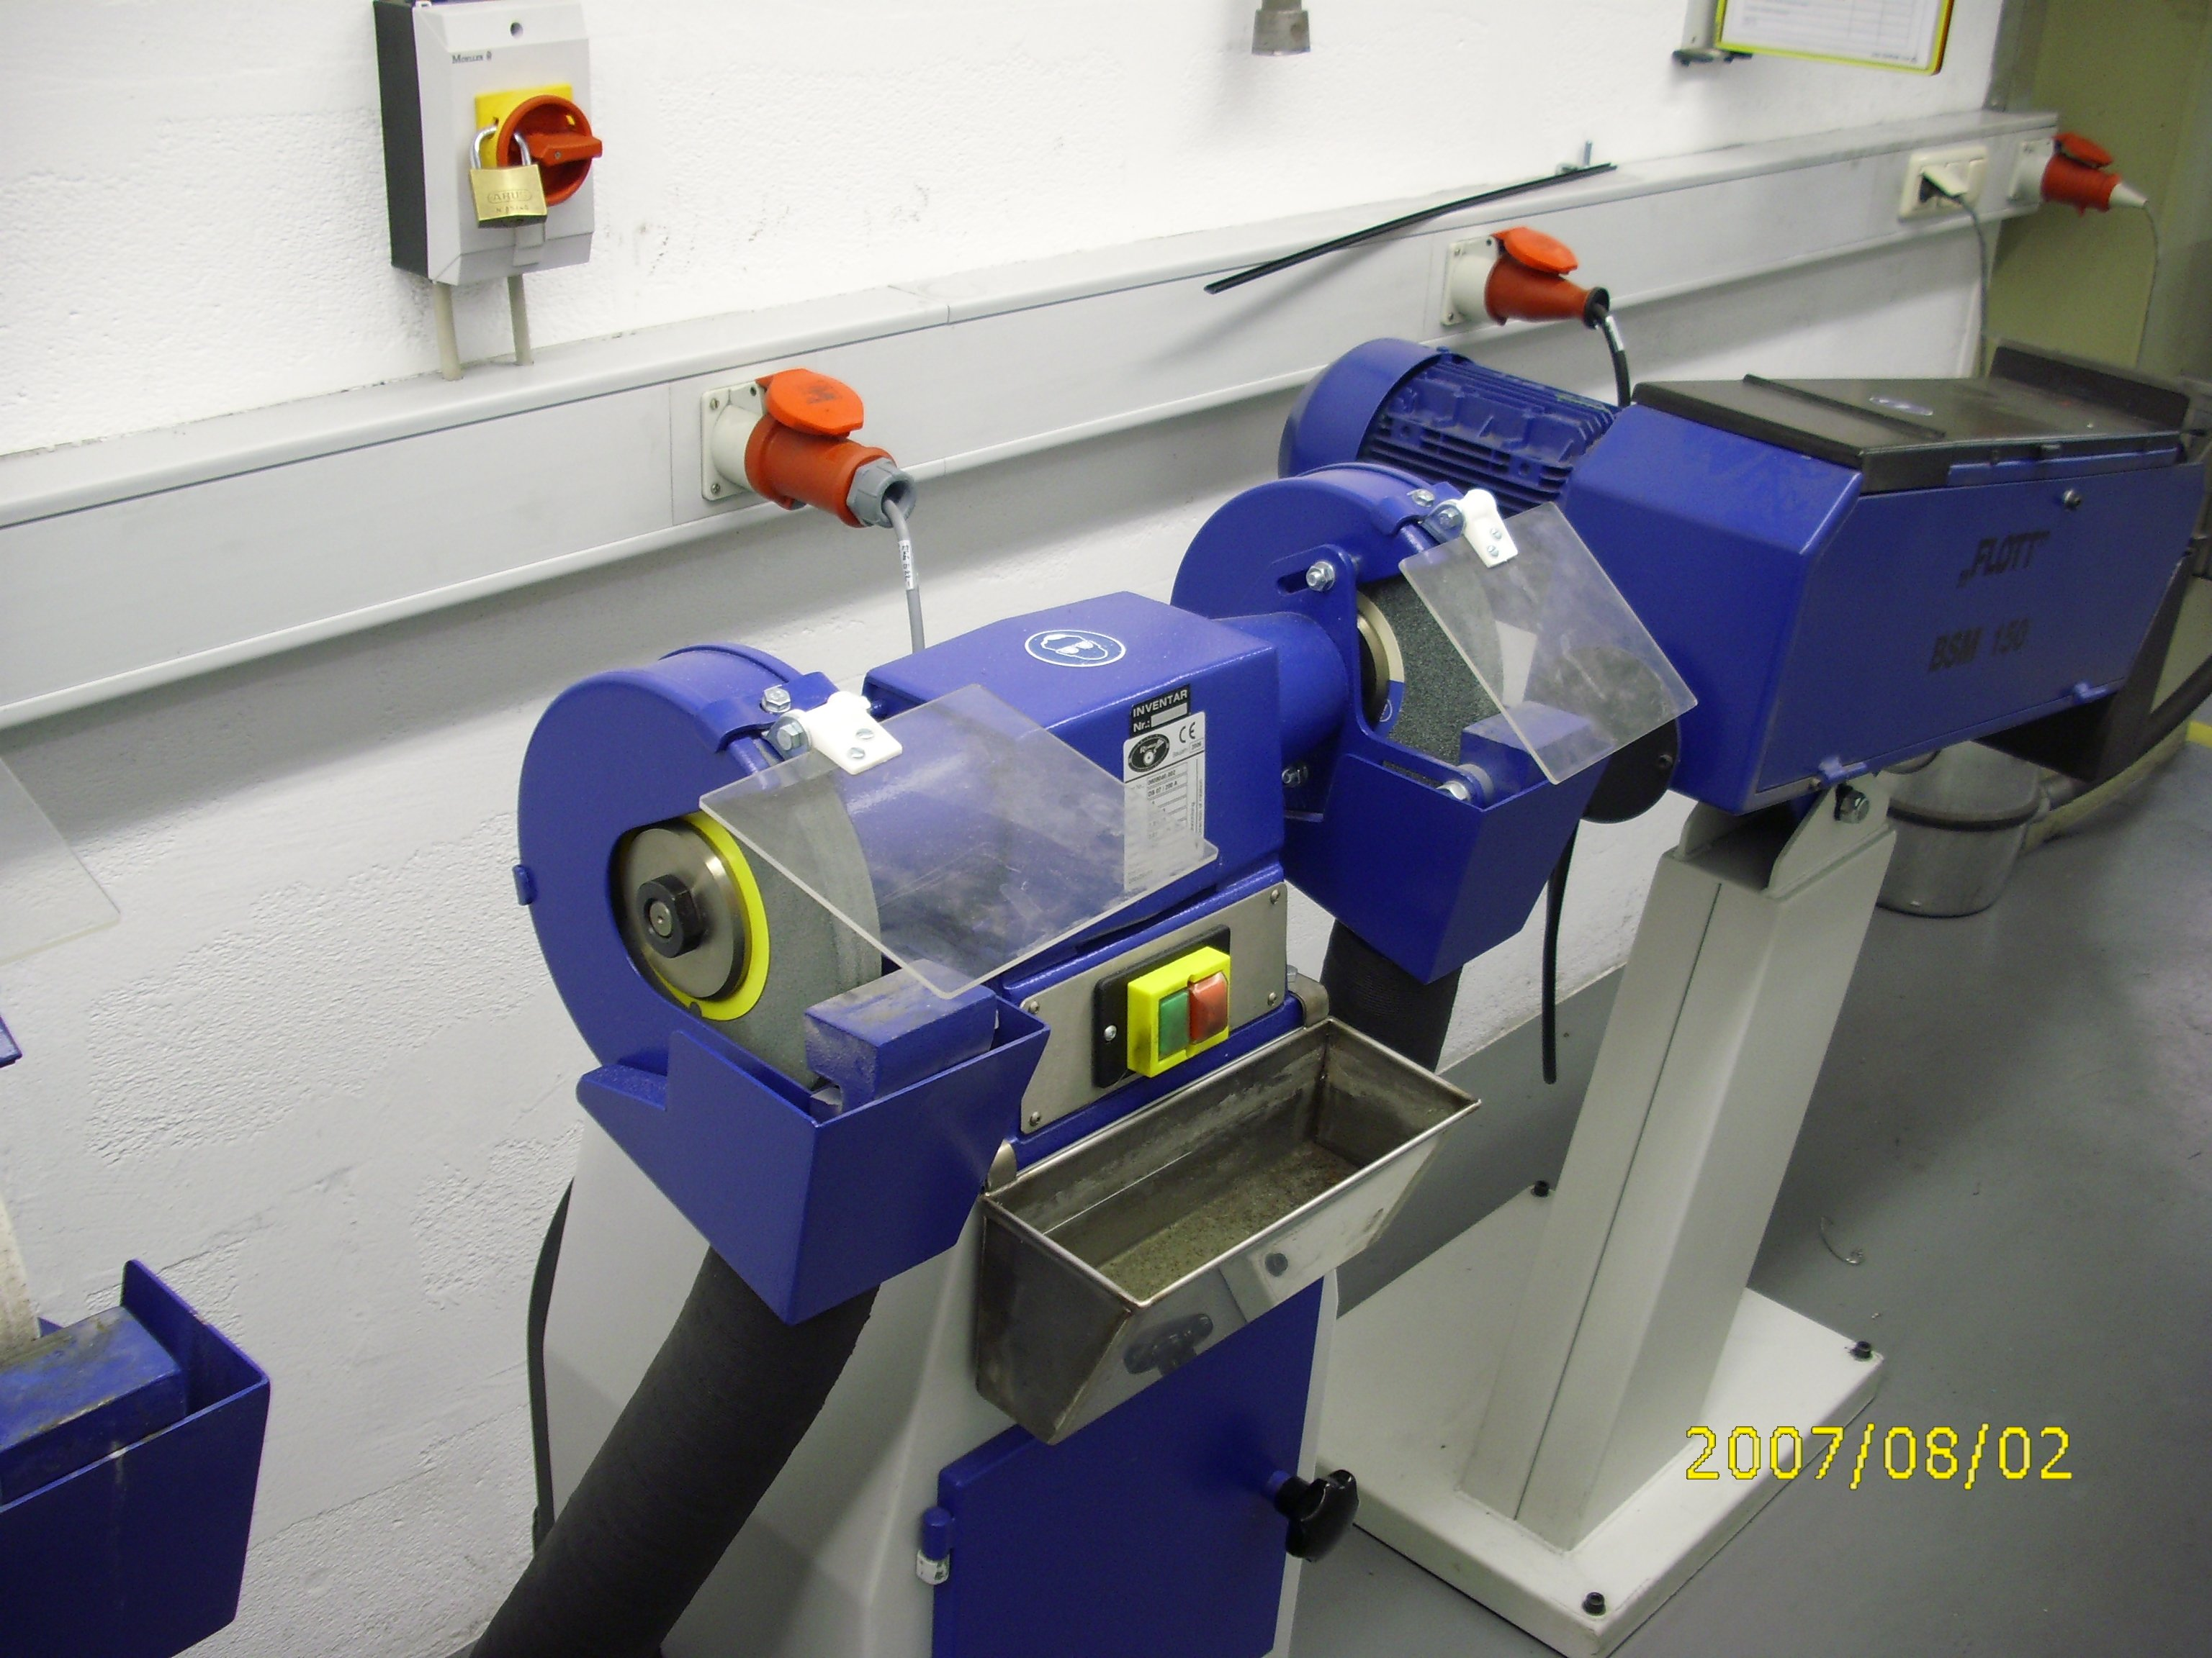

5.1

7.4

2.1 2.2

4.1

3.1

7.3

1. |  | Operating manual, circuit diagrams, technical data sheets
1.1 |  | Is an operating manual available for the machine?
1.2 |  | Are work instructions including safety advices available?
2. |  | General condition of the machine / system  Visual inspection; enclosures; barriers; cables; hoses; lines
2.1 |  | Have all enclosures and barriers been secured in a suitable manner and to an adequate extent (with safety bolts where necessary)? Grinding wheels min. 75 % enclosed (to the side as well)
2.2 |  | Are all enclosures and barriers in faultless condition?
2.3 |  | Has the machine been installed and secured in accordance with the manufacturer's instructions and to withstand the normal loads and stresses encountered in operational service?
3. | Hazards caused by gas, vapor, mist, liquid and dust  Visual inspection, working zone analysis, test record
3.1 | Have facilities been provided to restrain or extract dust (where necessary)?
4. |  | Command facilities  Visual inspection and function test
4.1 |  | Are the command facilities clearly recognizable as such and are their functions easily distinguishable?
5. |  | Shutting the machine / system down (switching off)  Function test; checking with reference to circuit documents and operating instructions
5.1 |  | Is there a master switch to turn the complete machine on and off and can this switch be secured with at least 3 locks?  Or appropriate fuse protection for the connector
6. | Lighting  Visual inspection;  measurement
6.1 | Are the working zones adequately illuminated for the work performed in them?
7. | Using equipment and facilities  Visual inspection; checking with reference to the operating manual and the instructions for use
7.1 | Is the equipment solely used for the intended purpose specified by the manufacturer?
7.2 | Does the maximum allowed sped of the grinding disk match the speed of the motor? (n _{Disk} > n _{Motor})
7.3 | Is there a material support? / Is the clearance correct (max. 3 mm)?
7.4 | Is there an adjustable and robust spark protection shield?
8. | Preventive and corrective maintenance work, cleaning  Checking with reference to the operating manual, the instructions for use and the maintenance schedule |  |  |  |  | Refer to FSS 1
9. | Identification markings  Visual inspection
9.1 | Does the machine bear the necessary safety identification markings and hazard warnings specified according to the statutory requirements in the country of use?
10. | Contact with electric current  Visual inspection and function test, checking with reference to the operating manual, measurement
10.1 | Does the equipment offer the employee protection against direct contact with electric current?
10.2 | Does the equipment offer the employee protection against indirect contact with electric current?

